|  |  |  |
| --- | --- | --- |
|  | **Rochester Institute of Technology**  **Golisano College of Computing and Information Sciences**  **School of Interactive Games and Media**  **2145 Golisano Hall – (585) 475-7680** |  |

**Data Structures & Algorithms for Games & Simulation II**

**IGME 309**

**Projection Matrix**

This exercise follows lecture D8

1. Under _Binary look for the example solution. It will look like this:

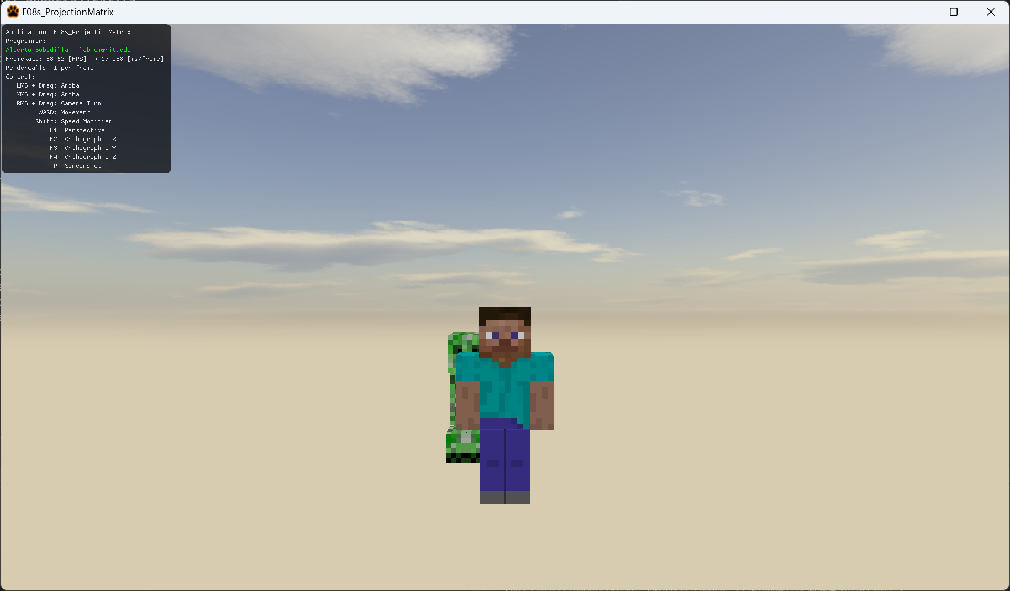

When you press buttons 0 to 1 the scene changes as follows (there is a small description as well on the AppClass.cpp file):

1 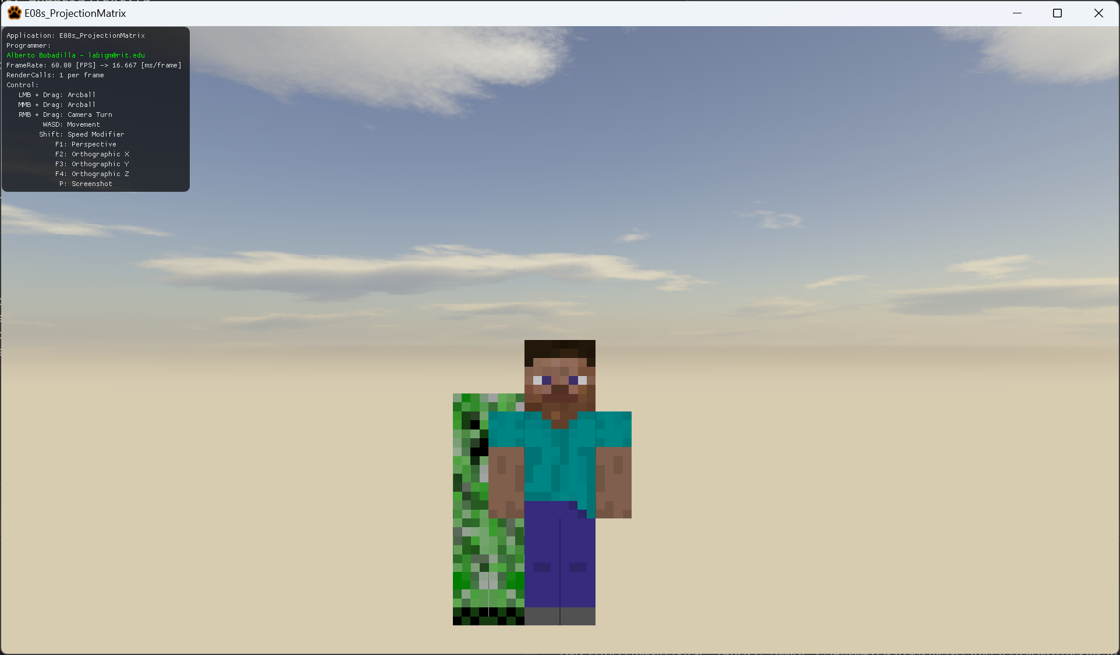

2

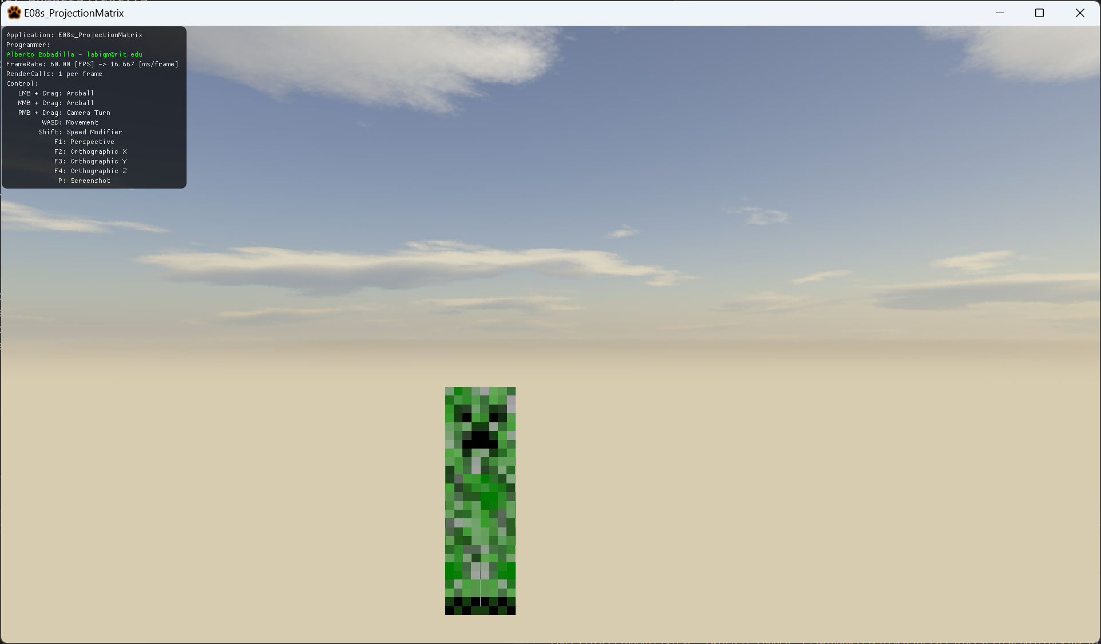

3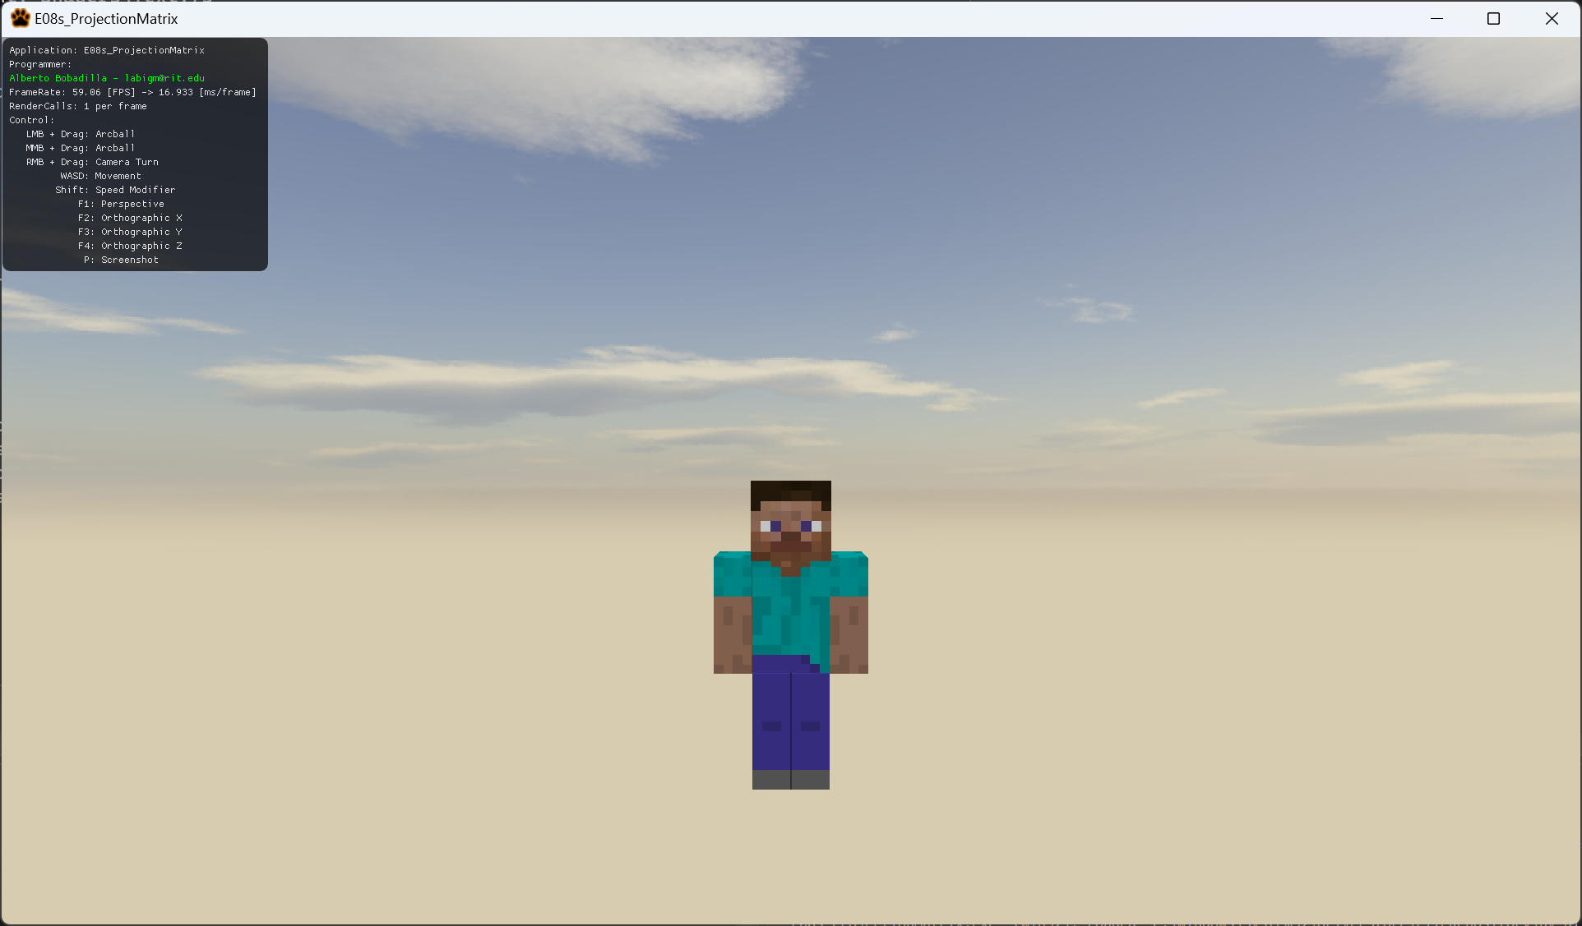

4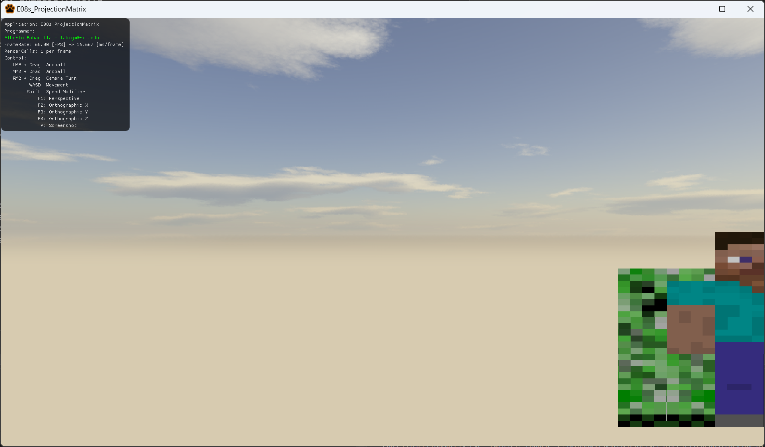

5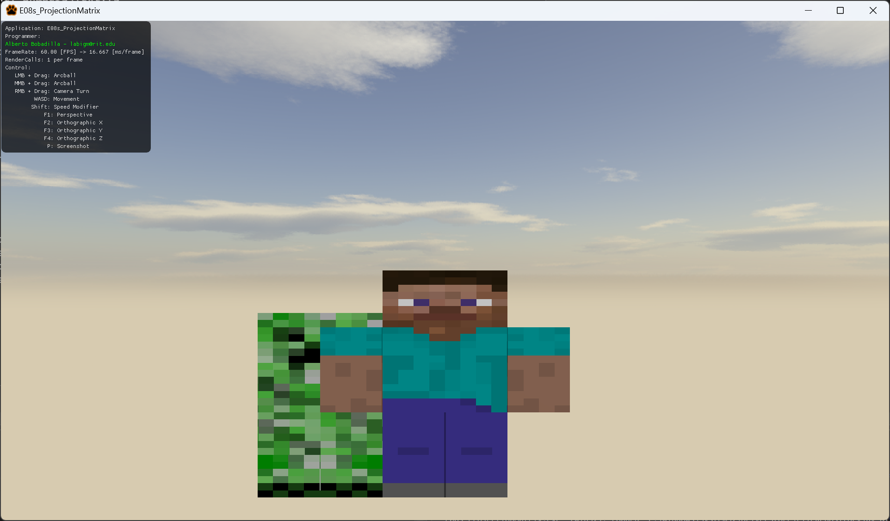

6

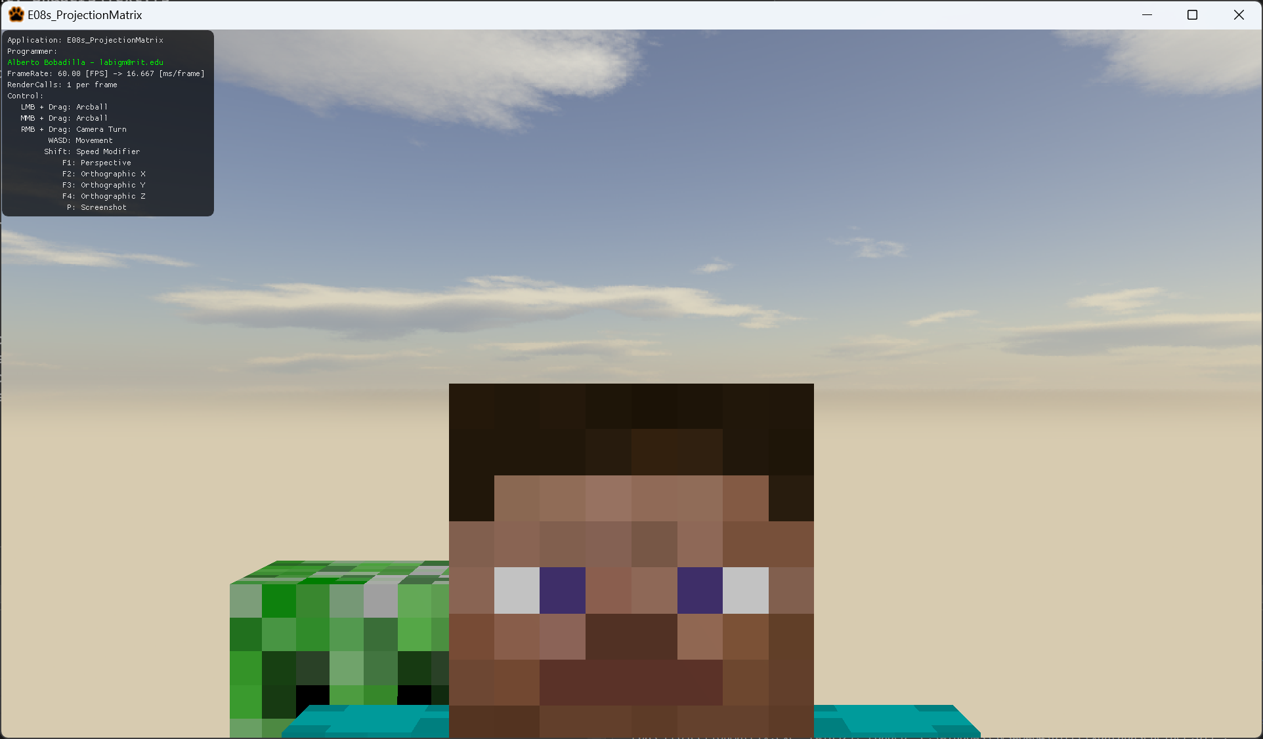

7

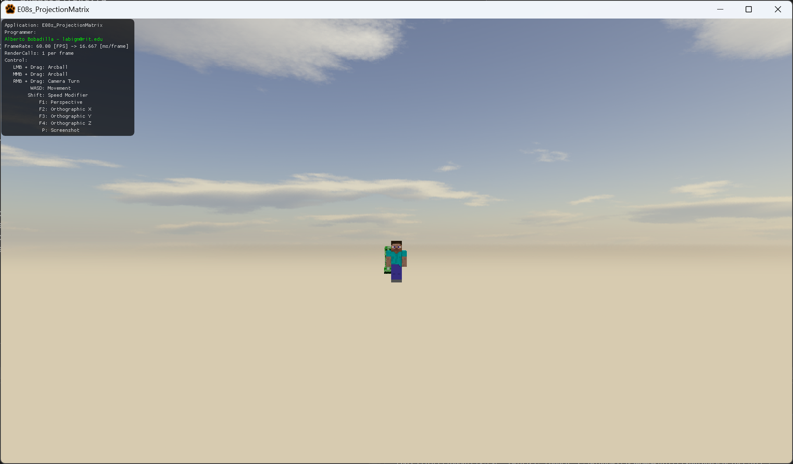

8

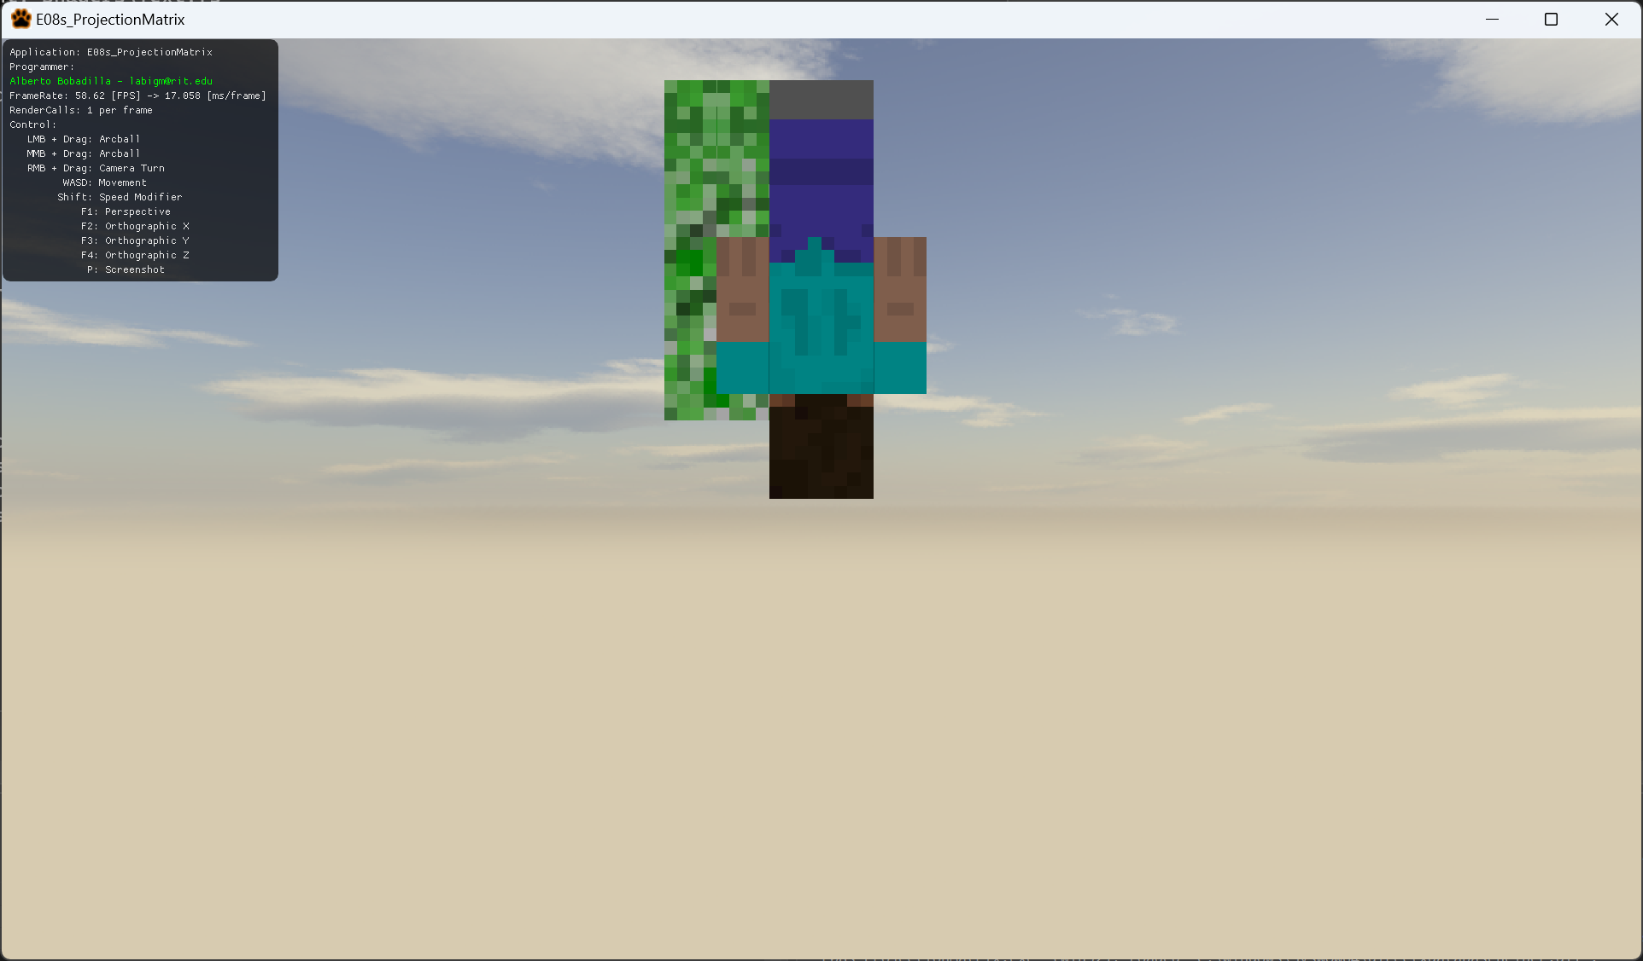

9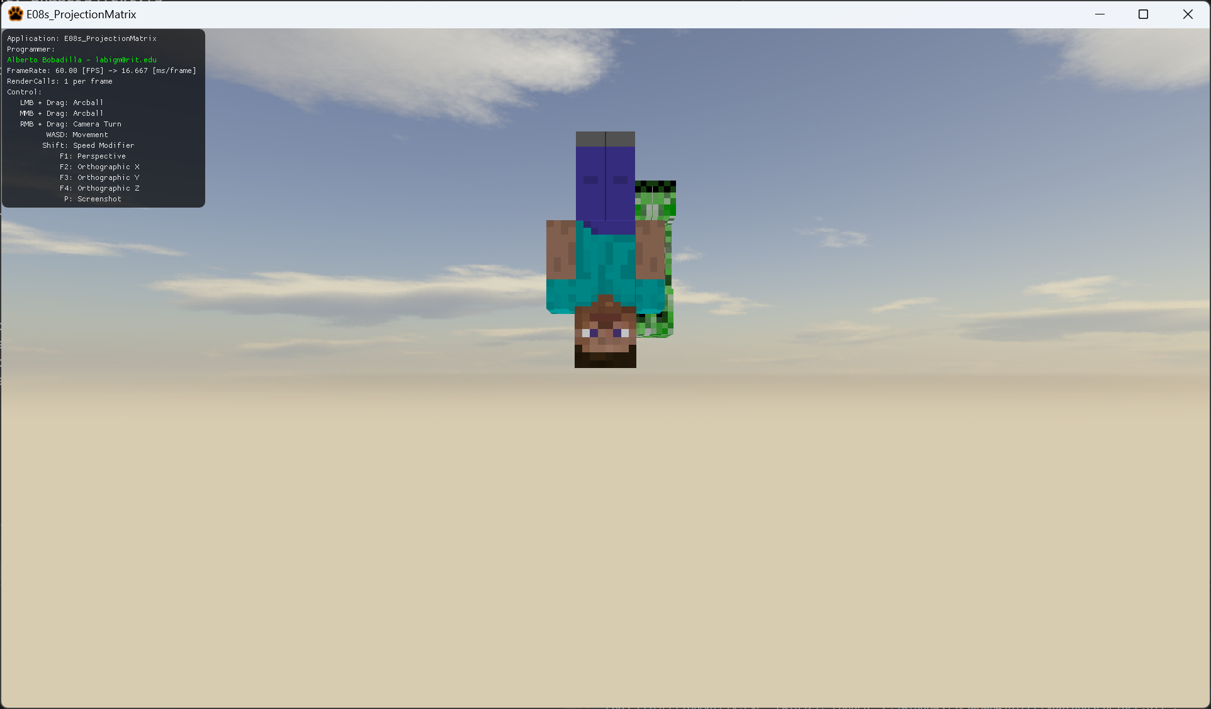

1. Your exercise is to replicate this scenes as close as possible (I do not care about exact numbers so long they resemble the scenes).
   1. You are only allowed to work in the AppClass.cpp file, under the switch statement in Update
   2. You are not allowed to change the camera’s position in any way. Only the projection matrix components.
   3. Everything is setup for you in the AppClassControls.cpp but you may take a look at how things work for the controllers if you want. There is nothing to modify in there.
2. As all your changes are in the AppClass.cpp please only upload this file to the dropbox

